1. **Beginners challenge:**

Create a dictionary with the following groceries and the corresponding price and print the key value pair

|  |  |
| --- | --- |
| **Item** | **Price** |
| Chocolate | 2 |
| Pizza | 10 |
| Flowers | 10 |
| Chips | 2 |

1. **Intermediate Challenge:**Create a program that allows user to type in the language they want “Hello” translated to.

If user inputs “French”, the program should output “Bonjour”

|  |  |
| --- | --- |
| **Language** | **Translation** |
| French | Bonjour |
| Spanish | Hola |
| Italian | Ciao |
| German | Guten Tag |
| Indian | Namaste |

1. **Intermediate Challenge:**

The following program was created by a co-worker to calculate the total price of items in a shopping cart but it has errors.   
Correct (and comment) the program to ensure it runs successfully

cart = {

'customer': 'Monty Python',

'store id': 101,

'item': [

{'name': 'Chocolate', 'quantity': 5, 'price'= 2}

{'name': 'Pizza', 'quantity': 2, 'price'= 10}

{'name': 'Flowers', 'quantity': 1, 'price'= 10}

]

}

total_price = 0

for x in cart['item']:

totalPrice += x['price']

print('Your total price is ${totalprice} plus tax")

**Homework 1**

Create a program that calculates a word point value in scrabble

Point values are found here <https://www.thewordfinder.com/scrabble-point-values.php>

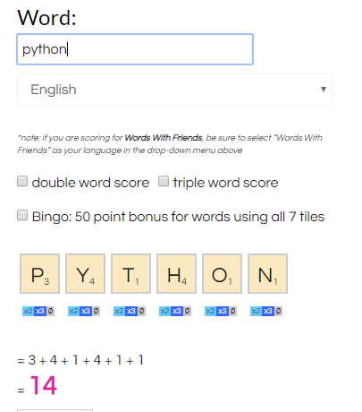

Figure 1 http://www.thekatespanos.com/scrabble-score-calculator/

**Homework 2**

Improve the dictionary translator created in classwork 2:

* Use a loop to keep the program running until the user types ‘quit’
* Use a conditional statement (if statement) to allow users to words to the dictionary if the language is not defined